* Face Matching Using FBG
  + Obtain approximate face position for an image using a condensed FBG (each bunch is averaged)
  + ▸ Refine face position using the full FBG
  + ▸ Result is a fitted graph for an image
  + ▸ Fitted graphs for two face images are compared by taking the average similarity between the jets at each corresponding landmark

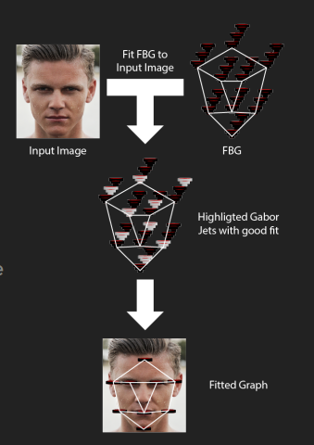

* 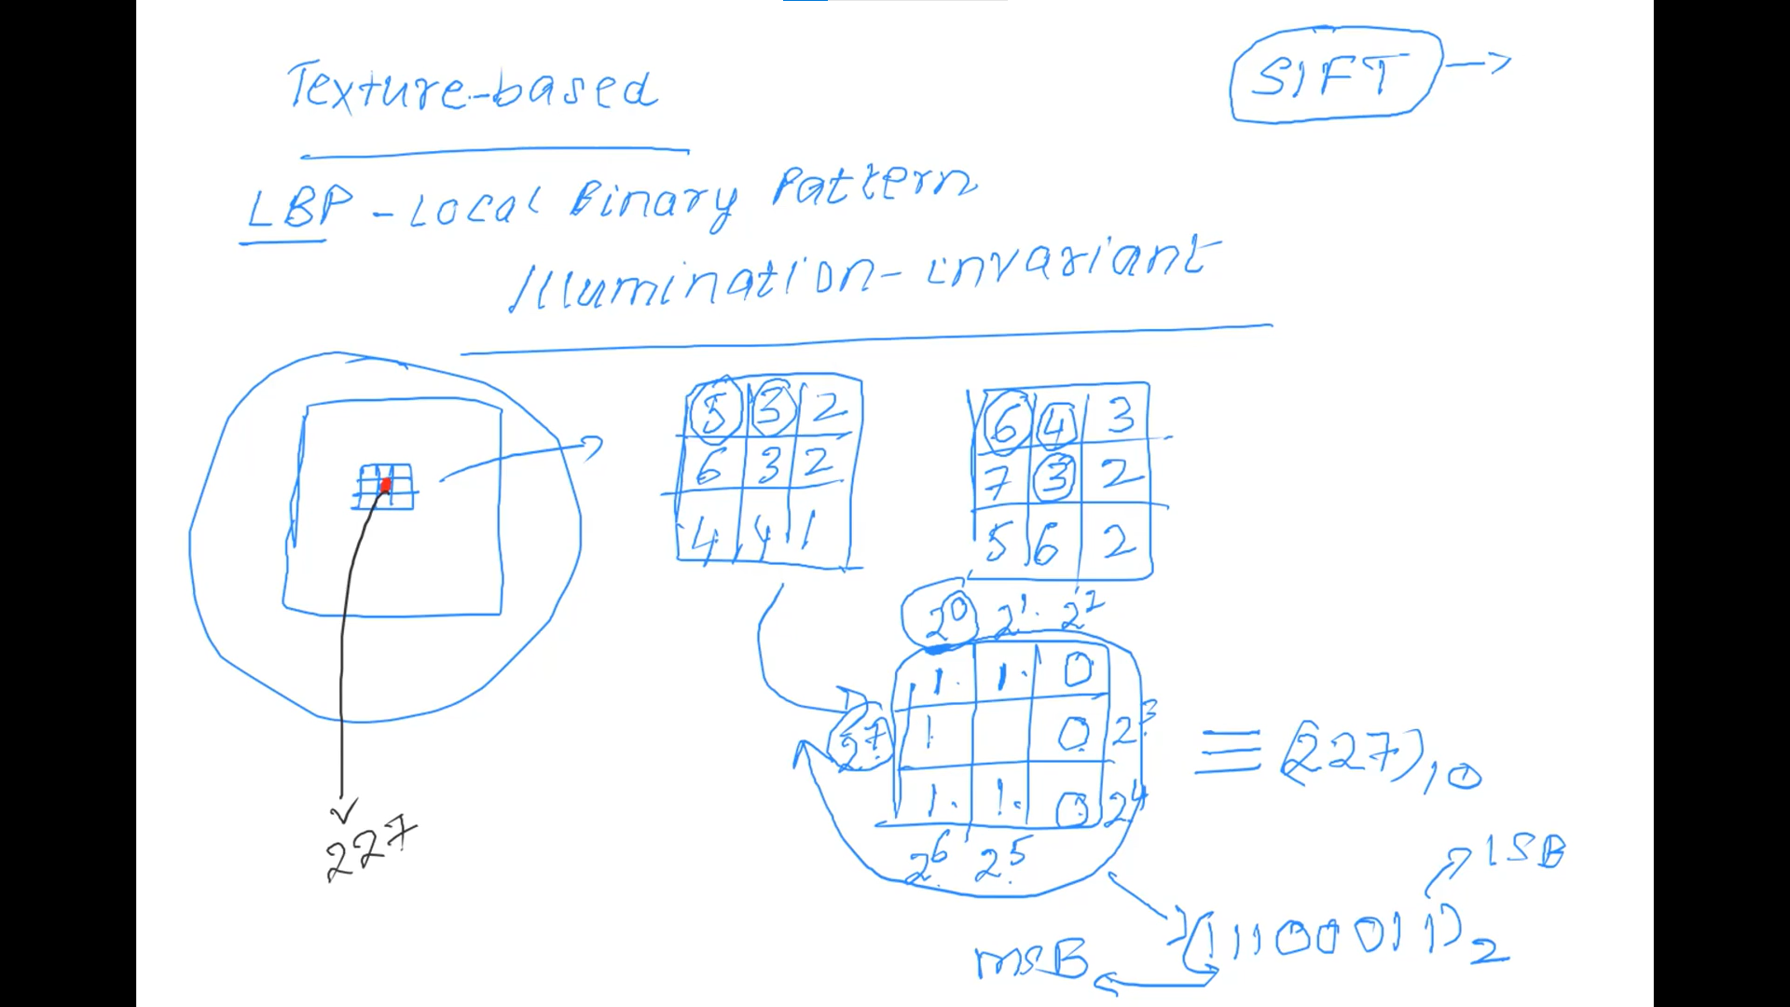

Face Images are typically acquired using a VIS spectrum camera like a camera on your phone

▸ Viola-Jones uses a cascade classifier to detect faces

▸ PCA learns a subspace from the training data

▸ LDA learns a subspace similar to PCA but takes into account the class label (i.e., the subject ID)